**logobox[1]Mac Basics**

Works Consulted

GCF Learn Free: OS X Basics: <http://bit.ly/1Q86pBe>

Apple Support Shortcuts: <http://apple.co/1A1wJEA>

Apple Support Switch Basics: <http://apple.co/1ggInaW>

Kathleen Weiss

Instruction and Technology Librarian

[kweiss@vapld.info](mailto:kweiss@vapld.info)

**Introduction**

OS X is the operating system designed by Apple for their MacBook laptops and iMac desktops. OS X comes preloaded into Apple Macintosh computers, commonly known as Macs. Mac OS has been around since the mid-1980s. The first version of OS X was was released in 2001 and the newest version is called OS X El Capitan, released in 2015. Even if you are running an earlier version of OS X at home, today's lesson is basic enough that your knowledge will be applicable to earlier versions of OS X. OS X allows you to complete everyday tasks such as accessing the internet, checking email, editing digital photos, listening to music and playing games. OS X contains additional productivity tools such as a calendar, word processor, and spreadsheet tool.

**The Desktop**

The desktop is the main workspace on the computer where you view and manage files, open applications, access the internet, and more.

**Desktop Orientation:**

* **Apple Icon**: access system preferences, recent documents, and more. Shut down, restart, and log off your computer from here too.
* **Menu Bar**: contains different menu options depending on the active program you are using. By default the menu bar contains the Finder application.
* **Date, Time, and Wi-Fi Settings**: find the Date and Time listed here along with other important shortcuts such as Wi-Fi and Battery Life. There may be more shortcuts available on different machines. (On our class Macbooks, there is no sound control from here. Instead you'll find it on the keyboard.)
* **Spotlight Search**: when you click the magnifying glass icon, it will open Spotlight Search. Spotlight Search allows you to find a file or application by typing the name (or just part of the name).
* **Notification Center**: displays an alert when you've received an update. You can customize the notification center to alert you of upcoming appointments or other events.
* **Finder**: is the file navigation application inside of OS X. Finder is always open.
* **Desktop Background**: the desktop background (wallpaper) is the background image on your desktop. You can customize this or use stock images found on the computer.
* **Folders on the Desktop**: you can keep folders, files, and shortcuts on the desktop so they'll be easily accessible.
* **Launchpad**: allows you to see a list of all of your applications. This is especially helpful as the Dock gets overcrowded very easily. (You can access the Launchpad by pressing F4 on your keyboard.)
* **Dock**: the Dock contains shortcuts to applications, files, and folders. You can switch between programs by clicking on a program icon on the Dock.
* **Trash**: When you delete a file, it is moved to the Trash. This allows you to recover the file if you change your mind. To permanently delete a file, you'll need to empty the Trash.

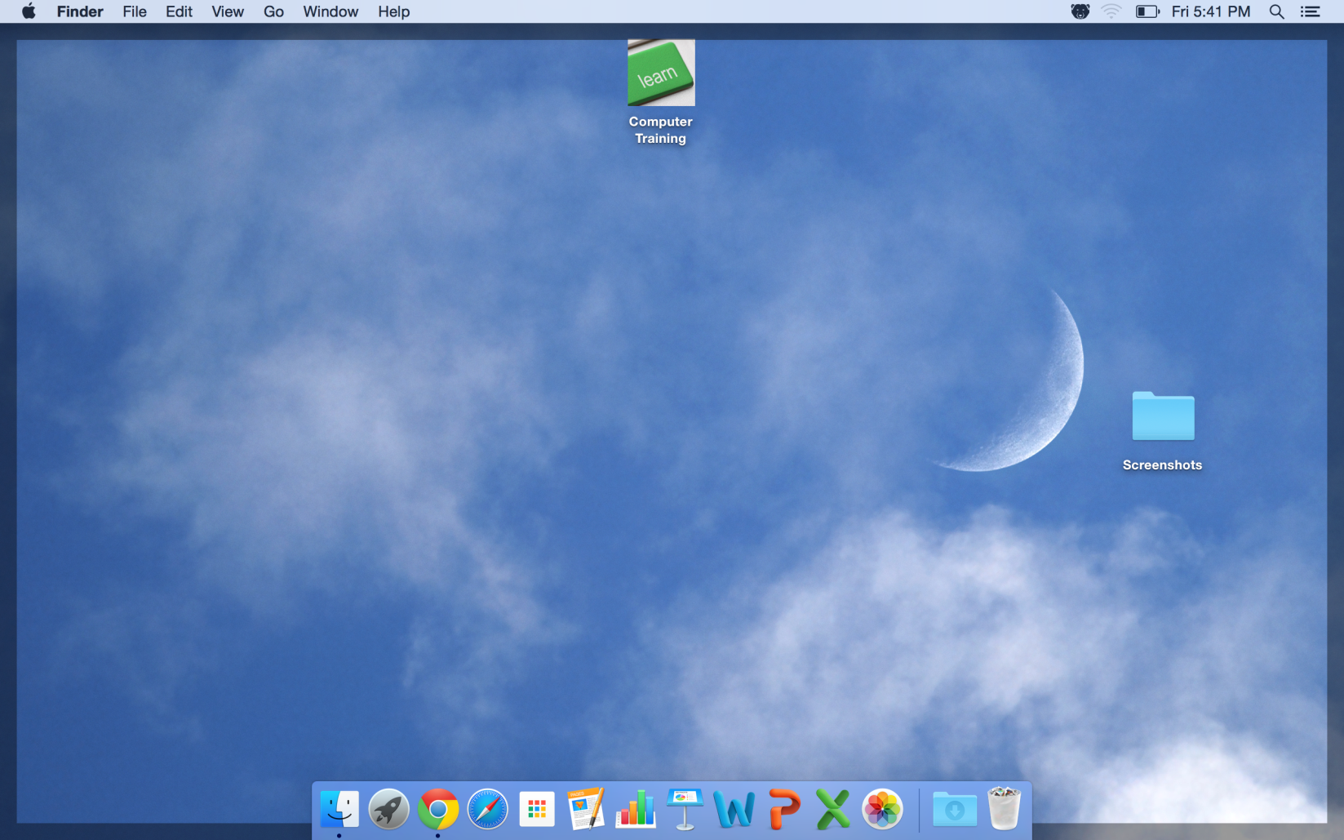

Finder

Trash

Launchpad

Dock

Folders on the Desktop

Notification Center

Spotlight Search

Date, Time, Wi-Fi Settings

Menu Bar

Apple Icon

Desktop Background

**Working with Applications**

Applications are pieces of software that allow you to complete a task on your computer. Examples of applications include Finder, Photos, and Safari.

**To open an application:**

1. Click on an application from the dock.

OR

1. Click on Spotlight Search.
2. Begin typing the name of your desired application.
3. When you see the name of the application you want to open, click on its name.

**Working with Windows**

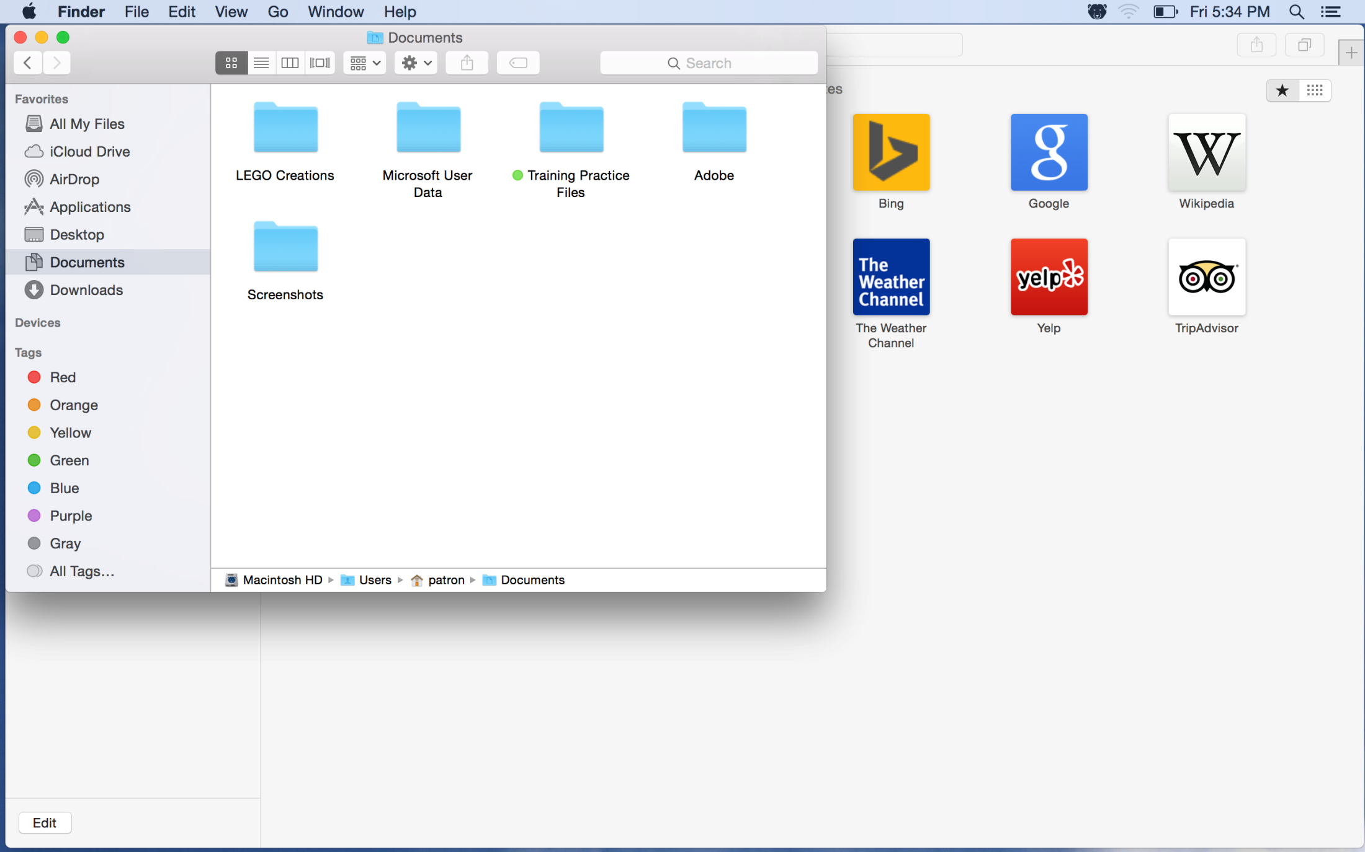Applications, folders, and files open in windows. You can have multiple windows open at the same time. The menu bar will change to reflect the active window.

**Window Orientation**

* **Application name** is listed in the upper left corner of the Menu bar.
* **Title bar** is located at the top of the window and designates the title of the current window. Not all windows have a title.
* **Close** is the red circle in the upper left corner. Click this to close the application window.
* **Minimize** is the yellow circle in the upper left corner. Click this to minimize your window to the Dock.
* **Maximize** is the green circle in the upper left corner. Click this to enlarge your application window.

**To move a window:**

1. Click the title bar and move the window to your desired location on the desktop.

**To resize a window:**

1. Hover the mouse over the lower right corner. Your mouse will change to a diagonal double arrow.
2. Click and drag the corner of your window. Release when done.

**Quitting Applications**

Unlike the Microsoft operating system, which quits an application when you close out of a window, Apple continues to run an application until you tell it to quit.

**To quit an application:**

1. Find the application menu bar at the top left corner of the desktop.
2. Click the application name.
3. From the drop down list, select Quit.

Alternatively, you can press Command + Q on your keyboard to quit an application.

**Shutting Down, Restarting, and Sleep Mode**

Shutting down your computer means you turn it completely off. No power is drained from the battery. When you’re finished using your computer, shut it down. If you plan to use the computer again soon, put it to sleep. Sleep mode is a power-saving mode in which most of the components in your computer are powered down. A notable benefit of sleep mode is that programs that were running when you put your computer to sleep will still be running when you wake it up. Your computer will automatically go to sleep if left unattended. To wake the computer, press any key or run your finger access the trackpad. Restarting your computer is helpful when your computer has become unresponsive.

**To Shut Down Your Computer:**

1. Click the Apple icon in the upper left corner.
2. From the drop down menu, click Shut Down.
3. From the "Are you sure you want to shut down your computer now" window, click the Shut Down button.

**To Restart Your Computer:**

1. Click the Apple icon in the upper left corner.
2. From the drop down menu, click Restart.
3. From the "Are you sure you want to restart your computer now?" prompt, click the Restart button.

**Working with Files**

A computer file is a resource for storing information on your computer. There are many kinds of files but most are text, image, or sound files. These files can be viewed or edited using applications on your computer. For example you might have an image file such as a photo that you open in an application such as Preview. The application allows you to view the file.

**File Icons**

All file types are represented with a different file icon.

**Folders**

A folder is a place where you can store multiple files to keep everything organized. Named folders can help you keep your files organized. OS X gives us some places to store folders by default. Examples include Documents and Images.

**Finder**

Finder is the application your Mac uses to organize files.

**To open Finder:**

1. Click the Finder icon on the Dock.
2. In the Finder application, you'll see a left and right pane. The left pane displays a list of locations where folders and files may be stored. The right pane displays the current folders and files you are looking at.

***If the left pane (sidebar) is missing:***

1. Click the View option from the Menu bar.
2. From the drop down menu, click Show Sidebar.

**To open a folder:**

1. Double-click a folder to open its contents.

**To preview a file before opening:**

1. Click once on the file icon.
2. Tap the space bar on your keyboard.
3. Press the ESC key to close the preview.

**To open a file:**

1. Double click on a file icon to open it.
2. The file will open in its default application.

Alternatively, you can also open an application and click the File option from the Menu bar. From the drop down, click the Open command and select a file to open.

**Opening Files in Different Applications**

When you open a file in OS X, it will usually open in the default application for that type of file. For example, a photo will open in Preview. But you may not always want this.

**To open a file in a different application or to change the default application:**

1. Right click on your desired file.
2. Click Open With and choose the desired application
3. To change the default application:
4. Right click your file.
5. Click the Get Info option.
6. Under the Open with option, select the desired application.
7. Click Change All.
8. Click Continue.

**To move a file:**

1. Click the file and drag it to the desired location.
2. Release the mouse. The file will appear in a new location.
3. You can use the same technique to move an entire folder.

**To create a new folder:**

1. Within Finder, select File from the Menu bar.
2. From the File drop down, select the New Folder option.

Alternatively, you can pressCommand + N on your keyboard.

**To rename a file:**

1. Click the file or folder you want to rename.
2. Wait about one second, and then click again. An editable text field will appear.
3. Type the desired name on your keyboard, and press Enter. The name will be changed.

**To delete a file or folder:**

1. Click and drag and file or folder you want to delete to the Trash.

To permanently delete a file or folder, click and hold the Trash icon, then select Empty Trash.

**Finding Your Files**

There are many places where you might find files on your Mac. Below are the four most common ways to locate files on your Mac.

**Recent Items List**

The recent items list shows a list of recently used or edited applications and files.

**To access Recent Items:**

1. Click the Apple icon in the upper left corner.
2. From the drop down list, click Recent Items.
3. Click the name of the application or file you would like to access.

**Finder**

The Finder application is the default file manager used is OS X. All of your files and folders may be found in Finder.

**To locate a file using Finder:**

1. Click the Finder icon on the Dock.
2. Use the left sidebar to select the correct location. For example, a text file is probably in Documents while an image file is located in Pictures.
3. Double-click on your desired file from the right pane to open the file.

**Spotlight Search**

Spotlight Search searches your Mac using the name of your file.

**To locate a file using Spotlight Search:**

1. Click the Spotlight Search icon in the upper right corner. (It looks like a magnifying glass.)
2. Type the name of your desired file.
3. Click the name of the file from your search results.

**Downloads Folder**

You may download a file from the internet such as an attachment. When you do, the file can be found in the Downloads folder.

**To located a file in the Downloads folder:**

1. Click the Downloads folder on the Dock.
2. Double-click on your desired file to open it.

**Common Computer Tasks**

There are some common computer skills that will work the same way in almost any situation. Once you learn how to use these skills, you'll be able to use them to perform a variety of tasks on your computer. Below are some common commands you can use in almost any application, such as cut, copy, paste, and undo, as well as how to right-click the mouse in OS X.

**The Menu Bar**

Whenever you open an application, you'll be able to use the menu bar in the top-left corner of the screen. Each menu has a set of different commands that will perform a specific action within the program. While each application is different, there are some common commands that work the same way, no matter which application you're using. Whenever you open a program for the first time, try clicking on these menus to see the various options.

**Application Menu Commands**

Whenever you open a new application, the application name is always in the upper left corner to the right of the Apple icon.

**Click on the application name to:**

* Quit an application
* Learn about the program (Click About).
* Change preferences (Click Preferences).

**Click the File menu to:**

* Create a new file
* Open an existing file
* Save the current file

**Right-clicking the mouse**

Right-clicking is not automatically enabled on your Mac. Enabling right-clicking is great way to quickly access common menu options.

**To enable right-click:**

1. Click the Apple icon.
2. From the dropdown, select System Preferences.
3. Click Mouse, then choose secondary click.

**Cut, Copy, and Paste**

Many applications allow you to copy items from one place and paste them to another. For example, if you're working with a word processor, you might copy and paste text to avoid typing the same thing over and over. If there's something you want to move from one place to another, you can cut and paste instead.

#### **To copy and paste:**

1. Select the item you want to copy.
2. Right-click the mouse and select Copy from the menu that appears. Alternatively, you can press Command + C on your keyboard.
3. Locate and right-click the desired location for the item, then select Paste. Alternatively, you can press Command + V on your keyboard.
4. The item will be copied to the new location. Notice how the original text that was copied has not been moved or changed.

#### **To cut and paste:**

#### Select the item you want to cut.

1. Right-click the mouse and select Cut from the menu that appears. Alternatively, you can press Command + X on your keyboard.
2. Locate and right-click the desired location for the item, then select Paste. Alternatively, you can press Command + V on your keyboard.
3. The item will be pasted, or moved, to the new location.

**To copy and paste files:**

1. Right-click the file and select Copy from the menu that appears. Alternatively, you can press Command + C on your keyboard.
2. Locate and right-click the new location and select Paste. Alternatively, you can press Command + V on your keyboard. In our example, we'll paste the file to the desktop.
3. The duplicate file will appear. Notice how the original file has not been moved or changed. Also note that if you make a change to the original file, it will not update any copies of that file

**Undoing Changes**

Sometimes you will make a mistake when working in an application.

**To undo changes:**

1. Click the Edit option on the Menu bar.
2. From the drop down, select undo.

Alternatively, you may also press Command + Z to undo an action.

**Adjusting Your Settings**

You can use the System Preferences application to adjust the settings on your Mac. System Preferences basically functions as the Control Panel for your Mac.

**To open System Preferences:**

1. Click the System Preferences option from the Dock. (The icon looks like three stacked gears.)

OR

1. Click the Apple icon in the upper left corner.
2. From the drop down, select System Preferences.

**To adjust a setting:**

1. From the System Preferences window, click on the desired setting you wish to adjust.

**Flash Drives on a Mac**

**To connect a flash drive:**

1. Insert the flash drive into a USB port on your computer. You should find a USB port on the front, back, or side of your computer.
2. Open Finder and locate and select the flash drive from the Sidebar on the left side of the window. Note that the name of the flash drive may vary. You may also see the flash drive on the desktop. If so, double-click it to open the flash drive in a new Finder window.

If you don't see the flash drive on the desktop, go to Finder Preferences (you may have to click the desktop first to switch to Finder). Next, make sure the External disks option is checked on the General tab.

**Working with a flash drive**

Once you've connected a flash drive, you can work with it just like any other folder on your computer, including moving and deleting files.

**To copy a file from your computer to the flash drive:**

1. Click and drag the file from your computer to this window.
2. The file will be duplicated, and the new version will be saved to the flash drive. The original version of the file will still be saved to your computer.

**To copy a file from your flash drive to your computer:**

1. Click and drag the file from the window to your computer.

**To remove a file from your flash drive:**

1. Click and drag the file to the Trash.
2. Click and hold the Trash icon and select Empty Trash to permanently delete the file.

**To safely remove a flash drive:**

When you're done using a flash drive, don't remove it from the USB port just yet! You'll need to make sure to disconnect it properly to avoid damaging files on the drive.

1. In Finder, click the Eject button next to the flash drive. Alternatively, you can right-click the flash drive and select Eject.
2. You can now safely remove the flash drive from the USB port.

**Keyboard Shortcuts**

Keyboard shortcuts are combinations of two or more keys that you can use to perform a task that would typically require a mouse or other pointing device. Keyboard shortcuts can make it easier to work with your Mac, saving you time and effort as you work with applications.

**Using Shortcuts**

By pressing a combination of keys, you can do things that normally need a mouse, trackpad, or other input device.

To use a keyboard shortcut, hold down one or more modifier keys while pressing the last key of the shortcut. For example, to use the shortcut Command + C (copy), hold down Command, press C, then release both keys. Mac menus and keyboards often use symbols for certain keys, including the modifier keys:

* Command ⌘
* Shift ⇧
* Option ⌥
* Control ⌃
* Caps Lock ⇪
* Fn

**Most Common Keyboard Shortcuts for Mac**

|  |  |
| --- | --- |
| Shortcut | Description |
| Command + X | **Cut**: Remove the selected item and copy it to the Clipboard. |
| Command-C | **Copy** the selected item to the Clipboard. This also works for files in the Finder. |
| Command-V | **Paste** the contents of the Clipboard into the current document or app. This also works for files in the Finder. |
| Command-Z | **Undo** the previous command. You can then press Command-Shift-Z to Redo, reversing the undo command. In some apps, you can undo and redo multiple commands. |
| Command-A | **Select** All items. |
| Command-F | **Find**: Open a Find window, or find items in a document. |
| Command-M | **Minimize** the front window to the Dock. To minimize all windows of the front app, press Command-Option-M. |
| Command-N | **New**: Open a new document or window. |
| Command-O | **Open** the selected item, or open a dialog to select a file to open. |
| Command-P | **Print** the current document. |
| Command-S | **Save** the current document. |
| Command-W | **Close** the front window. To close all windows of the app, press Command-Option-W. |
| Command-Q | **Quit** the app. |
| Command-Option-Esc | **Force Quit**: Choose an app to force quit. Or press Command-Shift-Option-Esc and hold for 3 seconds to force just the front app to quit. |
| Command–Space bar | **Spotlight**: Show or hide the Spotlight search field. To perform a Spotlight search from a Finder window, press Command–Option–Space bar. If you use multiple input sources to type in different languages, these shortcuts change input sources instead of showing Spotlight. |
| Space bar | **Quick Look**: Use Quick Look to preview the selected item. |
| Command-Shift-3 | **Screenshot**: Take a screenshot of the entire screen. Learn more screenshot shortcuts. |
| Command-Comma (,) | **Preferences**: Open preferences for the front app. |

**Switch Basics**

|  |  |
| --- | --- |
| In Windows | On a Mac |
| Right-click my mouse to access commands or perform actions in a shortcut menu. | You can use the right mouse button built into a mouse, or Control-click items (press and hold the Control key while you click) to access commands or perform actions from a shortcut menu.  To enable the secondary button on your mouse, choose System Preferences from the Apple menu. Click the Mouse icon, then choose your primary and secondary mouse buttons.  If you're using a trackpad, you can right-click by tapping with two fingers. You can turn this feature on or off in the Trackpad pane of System Preferences. |
| Press the Backspace key to delete or the Delete key to forward delete | Press the Delete key on an Apple keyboard to remove text while backspacing. It's in the same place as the Backspace key on a Windows keyboard. If you have a full size Mac keyboard, you can press the  key to forward delete. On a Mac notebook keyboard, hold the Function (Fn) and press Delete key to forward delete. |
| Use My Computer to see and access everything on my computer. | Open a Finder window, then choose Computer from the Go menu. From here you can view and access all the files on your Mac. You can also use Spotlight to quickly and accurately locate anything on your computer. |
| Use the Start menu and the taskbar to access programs, folders, and files. | Use the Dock and Launchpad to access applications or your favorite items.  To add your favorite apps to the Dock, drag them from another window to the left side of the Dock. To add your favorite documents and folders, drop them onto the right side of the Dock. Drag items away from the Dock to remove them. |
| Use Windows Explorer to find programs, files, and folders on my computer. | Use the Finder to find applications, files, or folders on your computer. To open a new Finder window, click the Finder icon on the Dock. |
| Use My Computer to access content from various drives, such as a hard drive or an optical disc. | You can find your connected drives and media in the Finder. Select the icon that appears in the Devices section of the Finder window, or choose Go > Computer. If you want your disks to appear on your desktop when they're connected, choose Finder > Preferences and enable the options you want in the General tab of the preferences window. |
| Use these keys as shortcuts:   * Shift key * Control key * Alt key * Windows key * Backspace key * Delete key | Use these keys as alternatives:   * ⇧ Shift key * ⌃ Control key * ⌥ Option key * ⌘ Command key * Delete key * Forward delete key |
| Press Ctrl + Alt + Delete to terminate unresponsive programs. | Press Command + Option + Escape (Esc) to force quit unresponsive applications. Once you press these keys, select any application from the Force Quit window and click Force Quit. You can also Force Quit an unresponsive app by clicking and holding its icon on the Dock. |
| Click the close box to close windows. | Click the round, red button in the upper-left corner of windows to close them. |
| Click the close box to exit programs. | To quit an app, choose Quit from the application menu, or press Command-Q. |
| Click the minimize box to minimize windows to the taskbar. | Click the round, yellow button in the upper-left corner of windows to minimize them. Minimized windows appear in the Dock. You can also use Command-M as a shortcut. |
| Click the maximize box to maximize my window. | Click the round, green button in the upper-left corner of windows to expand your window. In OS X Yosemite, clicking this button takes your app full screen. |
| Press a button to eject discs or disks. | Drag the disc, disk, or volume icon to the Trash (it turns into an Eject icon) to eject or unmount items. Or click the Eject icon next to the name of a volume in the Finder sidebar. |
| Press the Control (Ctrl) key for keyboard shortcuts (such as Ctrl + C to copy). | Press the Command key for keyboard shortcuts (such as Command-C to copy). |
| Press the Alt key as a modifier, or to type special characters. | Press the Option key as a modifier, or to type special characters (like é). You can also type accented characters by pressing and holding a related character on your keyboard. For example, press and hold the e key to see additional options like é ê é ë ē and more. |
| Perform various functions from window menus. | Perform various functions from menus in the menu bar at the top of your screen. The contents of the menu bar changes, depending on the app you are currently using. |
| Access Properties to set application, folder, or file options. | Use the Info window to set application, folder, or file options. To open an Info window, select an item and choose Get Info from the File menu, or press Command-I. |
| Move unwanted files and folders to the Recycle Bin. | Drag unwanted files and folders to the Trash in the Dock. To empty the Trash, choose Empty Trash from the Finder menu, or press Shift + Command + Delete in the Finder. You can also select the file that you would like to delete and use Command-Delete as a shortcut. |
| Rename documents by clicking Rename this file in the File Tasks menu. | Select any file, folder, or application and press the Enter key to display the name in a text box. Rename the item as anything you like by typing over the text. |
| Use the Performance control panel to check system performance. | Use Activity Monitor to check system performance. Activity Monitor is in the Utilities folder of the Applications folder. |
| Make shortcuts to an item by dragging and pressing Alt or make a copy by dragging and pressing Ctrl. | To make an alias to an item, click it once and from the File menu choose Make Alias, or press Command + L. Or drag the item while pressing the Command key and the Option key. A black arrow will appear over the icon. Drop the item to make an alias.  To make a copy of an item, select it and from the File menu choose Duplicate, or press Command + D. Or drag the item while pressing the Option key. A green Add circle will appear over the icon. Drop the item to make a copy. |
| Store and access files in My Documents and My Pictures folders. | Store files and content in your Documents and Pictures folders.  To access your Documents and Pictures folders, open Finder and select Documents or Pictures from the favorites list of the Finder sidebar. In Finder under the favorites list, you also have folders to store your music and movies. |
| Use Microsoft Photo Editor (or My Pictures) to view and edit pictures, Windows MovieMaker to edit my home movies, and Windows Media Player to listen to tunes. | You can use iPhoto to view and edit pictures, iMovie to edit your home movies, and iTunes or QuickTime Player to listen to tunes. iTunes also allows you to burn music discs, buy music and movies from the iTunes Store, and more. You can also use GarageBand to compose your own music. If you don't see these apps on your Mac, you can download them from the Mac App Store. Choose App Store from the Apple menu, then search for the apps you want to download. |
| Use Print Screen or ScreenTaker to take pictures of my screen. | To take a screenshot, press Command + Shift + 3. You can also use Grab or Preview to take pictures of your screen. |
| Use the Control Panel to customize various settings. | Use System Preferences to customize various settings. You can open System Preferences quickly by choosing it from the Apple Menu. |
| Use Network Connections to configure network settings. | To quickly select a Wi-Fi network, click the Wi-Fi icon in the menu bar at the top of your screen. You can use Network preferences in System Preferences to configure additional network settings. |
| Use Printers & Faxes to set up my printer and fax tasks. | Use Print & Scan preferences in System Preferences to set up your printer, scanner, or all-in-one device. |
| Use Device Manager to get information about my computer. | Choose About This Mac from the Apple menu to see information about your computer. You can also use System Information to see information in more detail. |