Intermediate Excel 2013
Exercise 1 - Creating a Workbook – After every line press the “Enter” key or arrow keys
Cell Type this data
A1 NPL-Intermediate Excel 2013
A3 Type your actual first and last name (example: “Nathan Smith”)
C5 Description
D5 Purchase Price
E5 Tax
F5 Total
C6 Laptop Computer
C7 Wireless Mouse
C8 Carrying Case
D6 1000
D7 30
D8 50
E6 =d6*0.09
E7-E8 Fill Down <Note: “fill down” – will copy the formula to the next row changing the row number>
F6 =d6+e6
F7-F8 Fill Down

Exercise 2 – Creating Totals using the SUM function

Cell Type this data
F9 =SUM(f6:f8)
Excel Formulas
A formula is a set of mathematical instructions that can be used in Excel to perform calculations. Formulas are started in the formula box with an = sign. An example: =d6+e6
Calculations: = (begins formula) + (add) - (subtract) * (multiply) / (divide)
^ (raise to a power) Example: 4^2 (4*4; answer 16)
There are many elements to an Excel formula. To create a basic formula in Excel:
- Select the cell for the formula
- Type = (the equal sign) and the formula
- <Note: Formulas follow the rules of algebra>
- Click Enter
- Some simple examples are on the next page
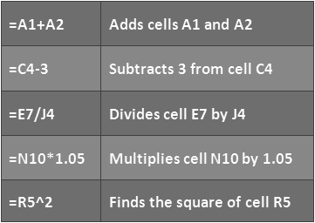
Calculate with Functions - A function is a built in formula in Excel. A function has a name and arguments (the mathematical function) in parentheses. Common functions in Excel:
Sum: Adds all cells in the argument
Average: Calculates the average of the cells in the argument
Min: Finds the minimum value
Max: Finds the maximum value
Count: Finds the number of cells that contain a numerical value within a range of the argument
Cell F9 contains the SUM function: =SUM(F6:F8)
“SUM” – name of the function
(F6:F8) – this is called the range; starting cell is F6, ending cell is F8 (meaning add cells F6+F7+F8

Exercise 3 - Inserting row – Do the following

- After row 7, insert:
- In cell C8: Software
- In cell D8: 100

Exercise 4 – Inserting a pie chart

- Select cells C5 to D9
- Click “Insert” tab on the Ribbon
- In “charts” group, select “Pie”
- Select “Pie in 3-D”

Exercise 5 – Changing chart type

- Click inside the white area inside chart
- In “charts” group, select “Column”
- Select “2-D Clustered column”

Exercise 6 – Validating formulas and functions

- Click the “Formulas” tab on the Ribbon
- Click in “Formula Auditing” group, select “Show Formulas”
Exercise 7 - Set Page Margins and Page Breaks:
- Click the Margins button on the Page Layout tab, then Select one of the choices, or
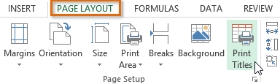
- Click Custom Margins
- Complete the boxes to set margins, then Click OK
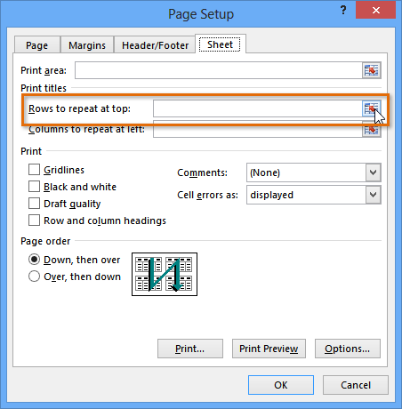
Inserting a page break
- Select the worksheet that you want to modify.
- On the View tab, in the Workbook Views group, click Page Break Preview.
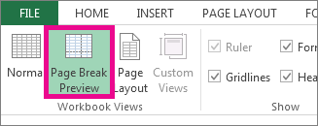
- TIP You can also click Page Break Preview on the status bar. (bottom of screen)
- NOTE If you get the Welcome to Page Break Preview dialog box, click OK. To not see this dialog box every time you go to Page Break Preview view, select the Do not show this dialog again check box before you click OK.
- Do one of the following:
- To insert a horizontal page break, select the row below where you want to insert the page break.
- To insert a vertical page break, select the column to the right of where you want to insert the page break.
- On the Page Layout tab, in the Page Setup group, click Breaks.

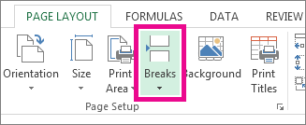
- Click Insert Page Break.

Exercise 8 – Set the Print Area
On the worksheet, select the cells that you want to define as the print area.
On the Page Layout tab, in the Page Setup group, click Print Area, and then click Set Print Area. NOTE The print area that you set is saved when you save the workbook.
Print a Range - There may be times when you only want to print a portion of a worksheet. This is easily done through the Print Range function. To print a range:
- Select the area to be printed
- Click the Print Area button on the Page Layout tab
- Click Select Print Area
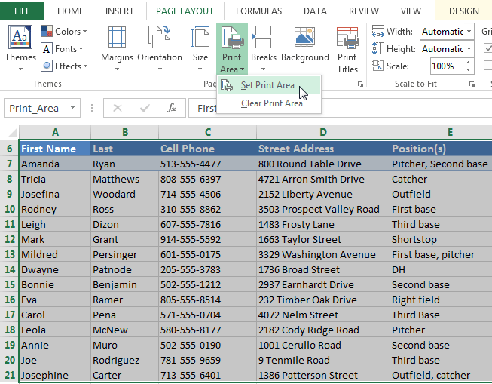

Exercise 9 – Page numbering

- Click “Page Layout” tab on the Ribbon
- Click in the bottom-right corner (diagonal arrow) of the “Page Setup” group
- In “Page Setup” menu, select the “Header/Footer” tab
- Click “Custom Footer”
- Insert “Page Number”, then Click “OK”, then “OK” again

Exercise 10 – Excel Templates
Microsoft Templates are canned worksheets that you can download and modify to meet your needs. Templates do most of the set-up and design work for you, so you can focus on your data. When you open Excel 2013, you’ll see templates for budgets, calendars, forms, and reports, and more.
Click the “File” tab, then click “New” along the left side of screen, then enter in search box: “Budgets”. Then choose a budget to download.
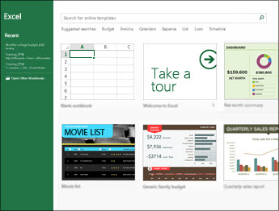

Tip – Use Google™, www.youtube.com, and www.gcflearnfree.org for assistance at home
For assistance with any Excel topic:

- In Google™ search box, type (example): Excel 2013 Tutorial “formulas”
- In www.youtube.com search box, type (example): Excel 2013 Tutorial “formulas”
- Here is an excellent tutorial website: www.gcflearnfree.org
Practice / Practice / Practice
The best way to retain what you learned today is to practice using Excel daily for the next several days.
Thank you for participating in Intermediate Excel 2013

Next Excel session: Advanced Excel 2013
Advanced Excel will cover: absolute addressing, IF function, conditional formatting, PMT function, goal seek, and much more.

