 | Netflix | Amazon Prime  Streaming Content Providers | HuluPLUS | CBS All Access | HBO Now | Sling | Vudu
Price | $7.99/mo | $99/yr ($8.25/mo) | $7.99/mo | $5.99/mo | $14.99/mo | $20/mo | Sign-up is free
Pros | - huge catalog of choices  - back episodes of TV shows  - no commercials  - no contract  - documentaries | - wide variety for free of low-cost  - free 2-day shipping  - free Kindle books | - current episodes  - exclusive Criterion Collection rights | - current episodes of CBS shows  - classic TV shows | - all of HBO  - subscribe from your Apple Device | - no long-term contract  - Includes ESPN, AMC, HGTV, etc. | - no subscription fees  - watch on any device  - rent or own what you want  - store digital copies of owned Blu-rays
Cons | - no current episodes  - frequent catalog changes | - no free current episodes (available for purchase)  - frequent catalog changes | - commercials  - less complete seasons  - no CBS shows | - only CBS  - not available of media hubs (access via website or app only) | - only available via Apple Devices (at this time) | - not available via web  - can’t stream in multiple places | - every item costs $  - if you cancel, you lose any purchased content
Shows | - House of Cards  - Marco Polo  - Orange is the New Black | - Downton Abbey  - Transparent  - The Sopranos | - Once Upon a Time  - American Odyssey  - The Tonight Show | - Blue Bloods  - The Good Wife  - The Young and the Restless | - Game of Thrones  - True Detective  - The Wire | - American Dad  - Rehab Addict Detective  - Rizzoli & Isles | - A.D.: The Bible Continues  - MadMen  - The Walking Dead

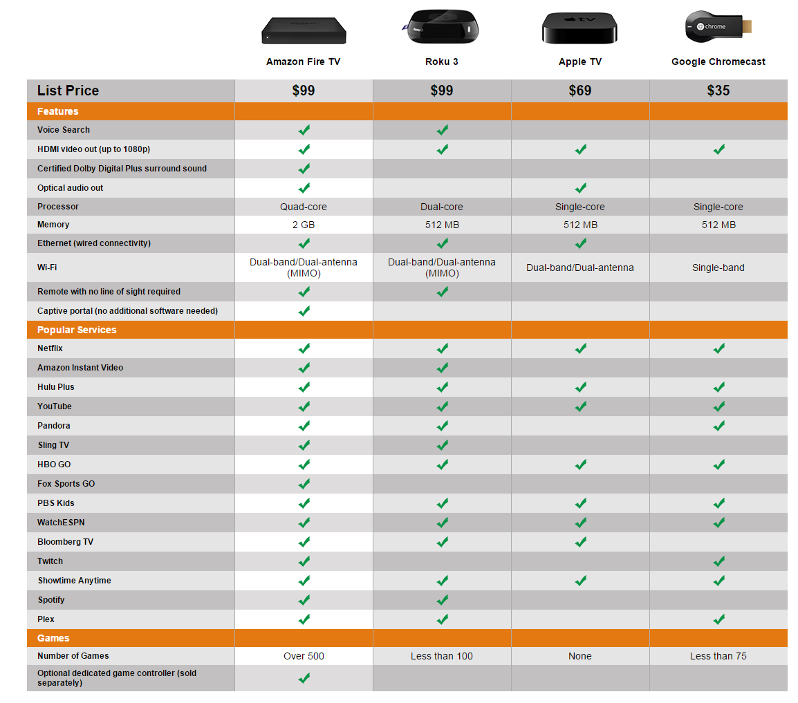
Media Hubs
(info from Amazon.com)
Media Hubs
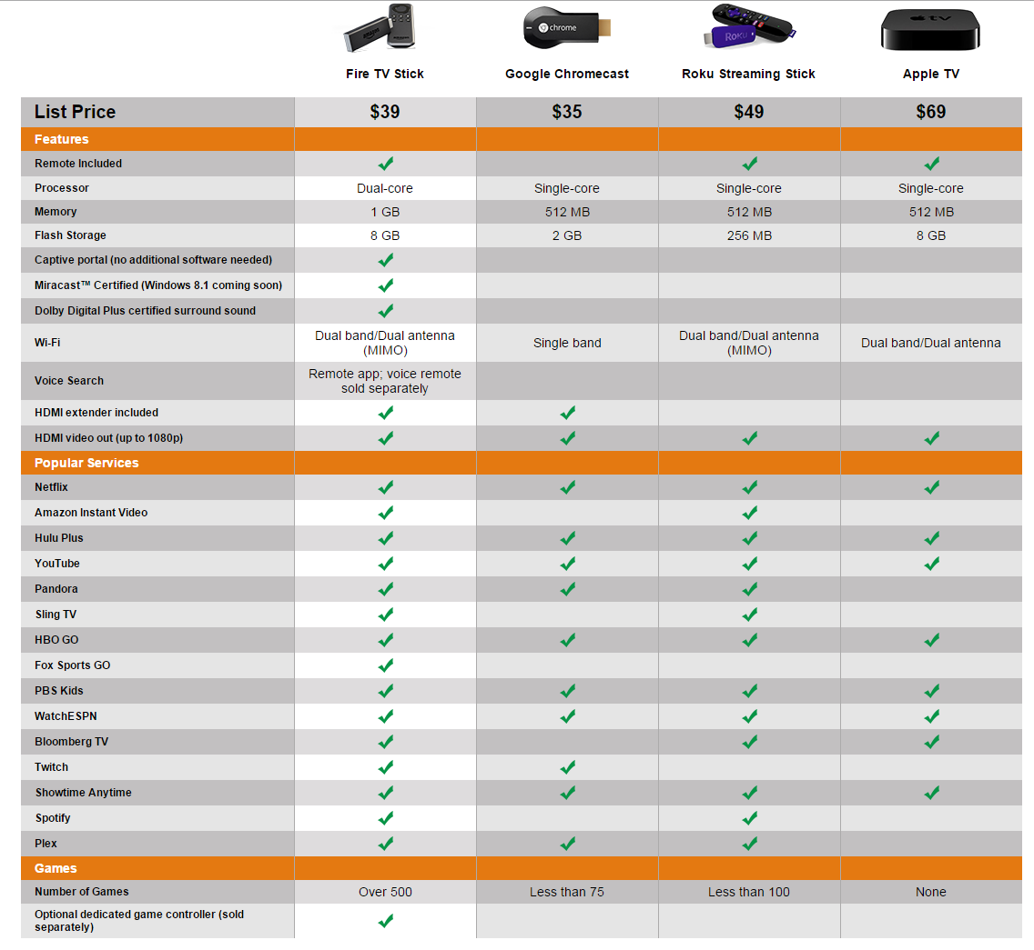
Media Hubs – Sticks
(info from Amazon.com)

